**Ideation Phase**

**Define the Problem Statements**

|  |  |
| --- | --- |
| Date | 18May2023 |
| Team ID | PBL-NT-GP-9119-1682672259 |
| Project Name | Automatic weather classification using transfer learning |
| Maximum Mark | 2 Marks |

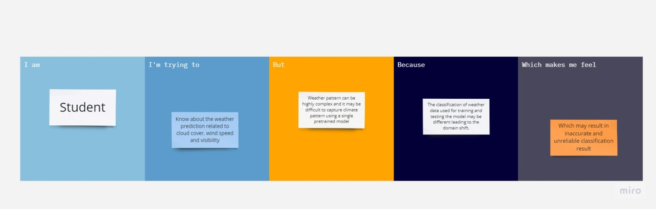

|  |  |  |  |  |  |
| --- | --- | --- | --- | --- | --- |
| **Problem Statement (PS)** | **I am (Customer)** | **I’m trying to** | **But** | **Because** | **Which makes me feel** |
| PS-1 | Pilot | I am trying to know about the cloud and visibility | But weather pattern may be complex and difficult to detect | Classification of weather data used for training and testing the model may be different leading to a domain shift | This can result in inaccurate and unreliable classification result. |
| PS-2 | Farmer | I am trying to about the if the weather is sunny or cloudy | But weather pattern may be inaccurate | Because of the global warming weather is always inaccurate | This can result in improper weather classification |